# PINETOWN DISTRICT

# INFORMATION TECHNOLOGY

# GRADE 12

# PAPER 2 (THEORY)

# TRIAL EXAM - 2014

**MARKS: 150 TIME: 3 HOURS**

**INSTRUCTIONS:**

1. ANSWER ALL QUESTIONS.
2. START EACH QUESTION ON A NEW PAGE.
3. WRITE NEATLY AND LEGIBLY.

**This exam paper consists of 13 pages (including this one)**

**And 6 questions …**

**QUESTION ONE**

***Various options are given as possible answers to the following questions. Choose the answer and write only the letter (A–D) next to the question number (1.1–1.10) in your answer book.***

1.1. _____ is a type of control that serves as an ‘on/off’ or ‘toggle’ fashion. Selecting it again

will clear the option.

A) Combo box B) Check box

C) Drop down list D) Radio button

1.2. Which statement is true, regarding the two hard drives in fig1 below, if this machine does

not have two HDD’s.

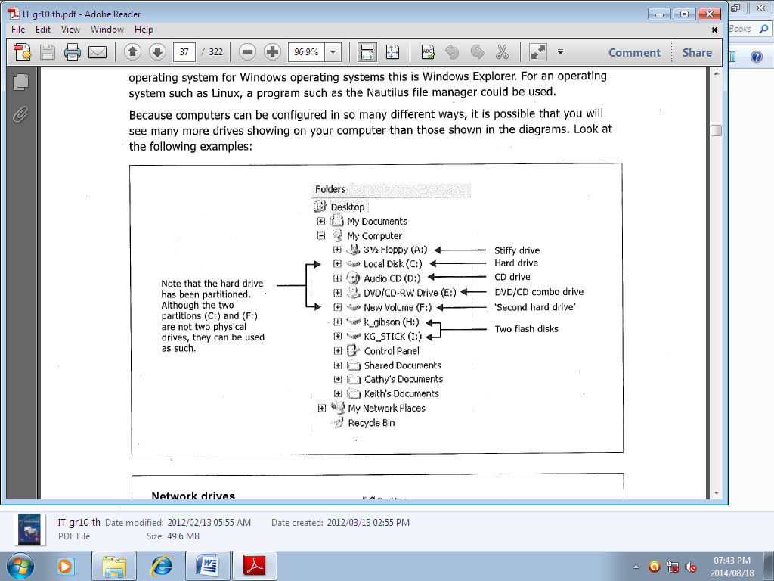

A) The HDD is partitioned into C: and F: drives.

B) The second hard drive is a network drive.

C) The second hard drive is a server or a shared drive.

D) The second hard drive is a new disk drive.

1.3. A type of software made available with a license that allows a person to access and

modify the source code, but they cannot sell the software.

A) Shareware B) Open source software

C) Freeware D) Shrinkwrap

1.4. Programs that add value and features to your system in the two main areas of   
 maintenance and security.

A) Utilities B) Drivers

C) Tools D) Application software

1.5Which of the following network standards uses short-range radio waves to transmit data.

A) IrDA B) WiMax

C) Bluetooth D) TCP/IP

1.6. Which of the following is not a function of the main/system board.

A) Supply power to all parts of the computer.

B) It stores the drivers for all the components connected to the computer.

C) It houses the CPU and provides a way for all other components to connect to and  
 communicate with the CPU.

D) Determines the parts that the computer can support, by type and number of   
 connection options it provides.

1.7. A program that re-orgnises the files and unused space on the computer’s hard disk so that   
 the operating system can access the data more quickly is called a _________.

A) Scandisk

B) Disk Defragmenter

C) Format

D) File allocation table

1.8. A computer on a network with reduced CPU, memory, storage or anything that indicates   
 that less power and is cheaper.

A) Stand alone B) Thin client

C) Dumb terminal D) Peer

1.9. Which of the ports below is most suited to connecting digital and video cameras to a   
 computer.

A) IDE B) USB

C) SCSI D) FireWire

1.10. _______ is a wireless network used for communication using devices such as cell  
 phones and PDA’s or other mobile devices relatively close to one another. It is mainly  
 for short simple tasks and depends mainly on Bluetooth.

A) GAN B) WAN

C) PAN D) LAN

[10]

**SCENARIO**

***A general practitioner, a dentist and a paediatrician decided to open a practice in a small complex in your community. They want to computerize their practices and gradually change all their paper documentation to electronic format.***

***Six computers are required, one for each of their offices, and one computers for each of their secretaries who will have their little cubicles at reception. They will share an all in one (printer, copier and fax). All the computers will be on a network located in the GP’s office.***

***They decide to spend money on quality computers instead of having to upgrade in the next two or three years. Internet is required in their field of work for: medical aid claims and other essentials of internet like e-mail, internet banking etc. You have been requested to help them with some terminology since you are more familiar with these terms as an I.T. learner.***

2.1. **The dentist was taking a closer look at the motherboard and its components as a  
 matter of interest and wanted to know some details regarding the different CPU’s:**

2.1.1. What is an instruction set? (2)

2.1.2. Pipelining is a technology that allows a CPU to work on multiple instructions at once.

Briefly describe how it does this. (2)

2.1.3. A diagram of the chipset was given to the dentist, in an attempt to show what

Components, the North Bridge and South Bridge manage. This diagram is incorrect.

Redraw the diagram and correct it by placing the labels in the correct place. (3)

USB PORTS

FIREWIRE

NORTH BRIDGE

PCI SLOTS

CPU

SOUTH BRIDGE

RAM

NETWORK CARDS

2.2. **The GP wants a new computer with an Intel i7 CPU. The i7 is a quad-core**

**hyperthreading 64-bit processor with the following features:**

**• 2.93 GHz core speed**

**• 8 MB of cache memory**

2.2.1. Explain the term hyperthreading. (2)

2.2.2. The part of the CPU used for temporary storage is called the registers. What name  
 given to the register that keeps track of the instruction the CPU is processing? (1)

2.2.3. The other storage area of the CPU helps make processing faster. What is this area  
 called, and how does it help make processing faster? (2)

2.2.4. This memory in 2.2.3 is very limited compared to regular RAM. Explain why this   
 is so. State TWO reasons. (2)

2.2.5. Even with all these attempts to increase the processing capabilities of processors, the  
 basic task of the CPU remains the same. Name the four basic steps in the Machine

Cycle of the CPU. (4)

2.3. **From the quotation specifications given in annexure A, list the following:**

2.3.1. Fastest processor of all three quotations and its speed. (2)

2.3.2. State two reasons, from the quote, why you would not recommend the i7   
 computer to the partners. (2)

2.3.3. List TWO characteristics of a Solid State Drive. (2)

2.4. **All three partners want to know why so much of fuss is made over the RAM of a**

**Computer. They were confused with the different types of RAM available and  
 needed clarity.**

2.4.1. DDR2 is an improved version of *DRAM* while *MRAM* is a newer type of RAM.

Differentiate between DRAM and MRAM in terms of the method that is used to   
 store data. (2)

2.4.2. Explain the concept of “paging” related to virtual memory. (2)

2.5. The doctors were advised to install cameras as a security measure.  
 They were also told that if cameras were used, they would need to install a UPS.

What does UPS stand for and what role does it serve? (2)

2.6. The GP wants to transfer the video footage to his home computer via the

Internet.

Explain why it is not a good idea to transfer these video files using the internet. (2)

**Total = 32**

**QUESTION THREE – e-Communication (Applications and Implications)**

|  |  |
| --- | --- |
| 3.1. **The business for the three practitioners is set up with six computers linked into a  client-server network with a proxy server and a web server.** |  |

3.1.1. State the function of a proxy server. (2)

3.1.2. Name TWO other kinds of servers besides a web server and a proxy server. (2)

3.2. The doctors want to maintain constant contact with each other surrounding medical  
 data. Besides e-mail, list two other ways in which they may communicate over the   
 internet. (2)

3.3. Apart from communicating, state TWO other useful activities that the Internet   
 provides that the doctors can make effective use of to improve their lives. (2)

3.4. **The doctors and their staff need to be informed about social networking websites  
 on the Internet.**

3.4.1. State TWO advantages of participating in activities on social networking websites. (2)

3.4.2. State TWO disadvantages of social networking websites. (2)

3.5. Provide the doctors with advice on how they can ensure that information found on  
 the Internet is reliable. (2)

3.6. **They want to also use on-line banking to conduct transaction from the office. To   
 do this it is important for them to understand that the website must be secure.**

3.6.1. List two ways to identify a secure website. (2)

3.6.2. State two advantages of on-line banking. (2)

3.7. **Phishing is always a risk when users are online.**

3.7.1. Explain what *phishing* is. (2)

3.7.2. How does *pharming* differ from *phishing*? (1)

**Total = 21**

**QUESTION FOUR: DATABASE MANAGEMENT**

4.1. ***Data integrity* is another common term associated with database design and operations.**

a) Name the two broad areas that data integrity can be split into. (2)

b) Explain what physical data integrity refers to? (1)

c) Give two hardware schemes or devices that can help ensure the physical  
integrity of data. (2)

4.2. Explain what data security is and name **two** ways to enforce it? (3)

4.3. **The tables below are used to store required information for the school**

**tuck-shop. Study the tables and answer the questions:**

|  |  |
| --- | --- |
| tblStock | |
|  | stockID |
|  | itemName |
|  | RetailPrice |
|  |  |

|  |  |
| --- | --- |
| tblOrders | |
|  | OrderID |
|  | OrderDate |
|  | Product |
|  | CostPrice |
|  | StockID |

4.3.1. What is a *primary key* and give an example of one from any of the   
 above tables. (2)

4.3.2. Which table contains the foreign key? (1)

4.3.3. You have an item name of which there is no other similar item. You want to   
know the date this item was ordered for the tuckshop. Explain how this can   
be done using the tables above. *Nb. no code is required just an explanation.* (2)

4.3.4. **Answer the following with reference to SQL code:**

4.3.4.1 Name an SQL function that can be used to find the cheapest item in stock. (2)

4.3.4.2 Write a SQL statement to display the **itemName** and **RetailPrice** from  
 tblStock. (2)

4.3.4.3Write a SQL statement to determine the total number of orders. (3)

4.3.4.4 Write a SQL statement to add an entry to the **tblStock** using the following   
input data:

stockID: 1234

itemName:Coke 340ml

RetailPrice: R10 (3)

**Total = 23**

**QUESTION FIVE: ALGORITHMS & SOLUTION DEVELOPMENT**

5.1) **The following class diagram has been designed to represent a client object.   
 Study the class diagram below and answer the questions that follow.**

|  |  |  |  |
| --- | --- | --- | --- |
| |  | | --- | | CLIENT | | Private Attributes  -ClientID  -ClientFirstName  -ClientSurname | | Public methods  + Constructor()  + Constructor(ClientID)  + Constructor(ClientID, ClientFirstName, ClientSurname)  + getFirstName():String  + getSurname():String  + setFirstName(ClientFirstName)  + setSurname(ClientSurname)  + toString():String | |
|  |
| 5.1.1.Use examples from the class diagram above to explain the concept   of *overloading* (2) | |
| 5.1.2. **Classes can contain accessor and mutator methods**  5.1.2.1) Briefly explain why a class may require an accessor method (2)  5.1.2.2) Give ONE example of an accessor method from the given diagram (1)    5.1.3. What is the usual purpose of a *toString()* method? (2)  5.2) **Study the algorithm below that supposedly calculates and displays the average  number of visitors per day, and then displays the days on which the number of   visitors exceeded the average number of visitors per week. The algorithm reads   the total number of visitors for each day of the week from the keyboard as test   data.**   |  |  |  |  |  |  |  |  |  |  |  |  |  |  |  |  |  |  |  |  |  |  |  |  |  |  |  |  |  |  |  |  |  |  |  | | --- | --- | --- | --- | --- | --- | --- | --- | --- | --- | --- | --- | --- | --- | --- | --- | --- | --- | --- | --- | --- | --- | --- | --- | --- | --- | --- | --- | --- | --- | --- | --- | --- | --- | --- | |  |  | |  |  | | --- | --- | | **Line number** | **Description** | | 1 | Create visitArr with a maximum of 5 values | | 2 | Create daysArr containing the names of the days of the week | | 3 | Initialise total to 0 | | 4 | Input number of visitors | | 5 | Start a loop to execute 5 times | | 6 | Input number of visitors | | 7 | visitArr[loop_value] 🡨 number of visitors | | 8 | total 🡨 total + visitArr[loop_value] | | 9 | End loop | | 10 | Display the average | | 11 | Start loop | | 12 | If visitArr[total] > average | | 13 | Display daysArr[loop_value] | | 14 | End loop | |  |  |  |  |  |  |  |  |  |  |  |  |  |  | | --- | --- | --- | --- | --- | --- | --- | --- | --- | --- | --- | |  |  | (5.2.1) | Redraw the following diagram representing the **visitArr** in your ANSWER BOOK.  **visitArr**   |  |  |  |  |  | | --- | --- | --- | --- | --- | |  |  |  |  |  |   (i) Use the given algorithm and the following test data to populate **visitArr** in the diagram in your ANSWER BOOK:  Test data: 8, 6, 9, 4, 1  (ii) You should have noted that the array has been incorrectly populated because of an error occurring in the algorithm. This error occurs between line numbers 1 and 9. Indicate how the algorithm must be changed in order to correct the error. |  | (2)  (2) | |
| (5.2.2) Assume that the error in the algorithm (referred to in  QUESTION 5.2.1 ii - has been corrected and that the array  has been populated with the following values:  **visitArr**   |  |  |  |  |  | | --- | --- | --- | --- | --- | | 8 | 6 | 9 | 4 | 1 |   The following is displayed by statements 10 to 14 of the algorithm:  0  Monday  Tuesday  Wednesday  Thursday  Friday  Rewrite statements 10 to 14 to display the correct average and the names of the days on which the number of visitors exceeds the average number of visitors per day.  **NOTE:** Additional statements might be required. |  | |  |

(3)

5.3) The following is an example of a GUI designed to capture details of a client.   
 Study the design and list FOUR ways in which the design layout and user-friendliness   
 can be improved. (4)

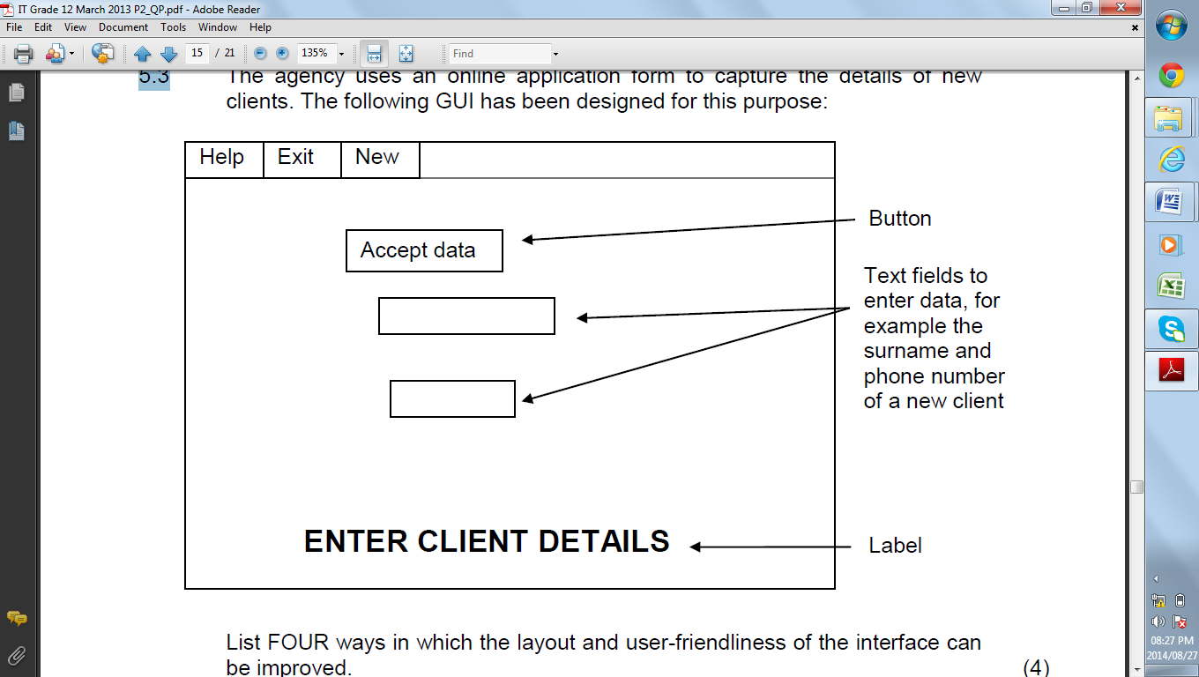

5.4 **In order to eliminate redundancy and increase accuracy of the data, a**

**database should be normalised, otherwise anomalies could occur.**

5.4.1 Explain what is meant by the underlined phrase. (2)

5.4.2 State **THREE** types of anomalies that could occur in a database (3)

5.5 Software should be free of errors. Therefore, debugging is an essential part

of the development of software.

State **TWO** methods of debugging a program. (2)

**Total = 25**

**INTEGRATED SCENARIO**

**QUESTION 6**

**HealthE has received a community grant to establish 100 clinics in disadvantaged rural communities around the country. Each clinic will receive a chief administrator, two clerks and a dispensary as well as three doctors. T improve their efficiency all their records will be computerized. The computers will also need to be networked**

|  |  |  |
| --- | --- | --- |
| 6.1 | **The main server in each clinic will make use of a RAID configuration. RAID1 or RAID5 is being considered.**   1. Explain the difference between *RAID 1* and *RAID 5* in terms of the way it handles data 2. What RAID configuration would you recommend? 3. Give a reason for your answer in(b) | (2)  (1)  (1) |
| 6.2 | **It has been decided that a client-server network be set up.**  State TWO benefits of such a network. | (2) |
| 6. 3 | **For any network to exit computers need to connect using some sort of medium**   1. Name TWO wired media that can be used. 2. Name TWO wireless media that can be used 3. Which type of medium would be best for connecting computers in the clinic. Give TWO reasons for your choice | (2)  (2)  (3) |
| 6. 4 | **All the clinics will be able to connect to each other around the country. To do this they will have to connect to the Internet.**   1. Whys is it likely that they will need to use 3G technology instead of ADSL(Remember they are rural clinics) 2. They are told that they will need an ISP. What service does an ISP provide 3. Each computer in the network will share an internet connection. What piece of hardware will be needed to connect the network to the Internet 4. Another piece of equipment is a firewall. Name TWO ways a firewall protects a network | (2)  (1)  (1)  (2) |
| 6. 5 | **HealthE decides to use the concept of *Cloud Computing.* As a consequence of this decision all their common administrative tasks will be done using online tools such as Google Docs**   1. Describe TWO advantages of using online software such as this 2. Describe THREE disadvantage of this type of system | (2)  (3) |
| 6.6 | **It was discovered that SQL injection was used to obtain user details from the clinic’s database through the internet**   1. What is an ***SQL injection*** 2. Explain how the website and database can be projected from an SQL injection | (2)  (2) |
| 6.7 | **HealthE will develop software that they will give to schools, businesses and members of the community for free. The software will educate people about good health habits, hygiene and medical care.**  One major drawback is the low level of literacy in the community. Describe TWO ways in which they can still get the message across with their software by using less text(less reading) | (2) |
| 6.8 | **Peter wants the public to know all about him and HealthE so he created a HealthE page on facebook**   1. He discovers that there is troll posting messages on the page. What is meant by a ***troll*** 2. Recommend TWO ways in which the social media manager can maintain a good profile of the clinic through social media. 3. Peter entered all his personal details on the facebook page including his name, phone number, email address and ID number.   Explain why this was foolish of him and give TWO ways that such information can be used against him | (2)  (2)  (2) |
| 6.9 | **The malware on the computers in one of the clinics has been described as spyware**   1. What is ***spyware*** 2. State TWO ways in which computers could be infected by malware | (2)  (2) |
|  |  |  |
|  | **Total =** | **40** |

TOTAL MARKS: 150

|  |  |  |  |  |  |
| --- | --- | --- | --- | --- | --- |
| **Q1** | **Q2** | **Q3** | **Q4** | **Q5** | **Q6** |
| 10 | 32 | 21 | 23 | 24 | 40 |

**Annexure A**

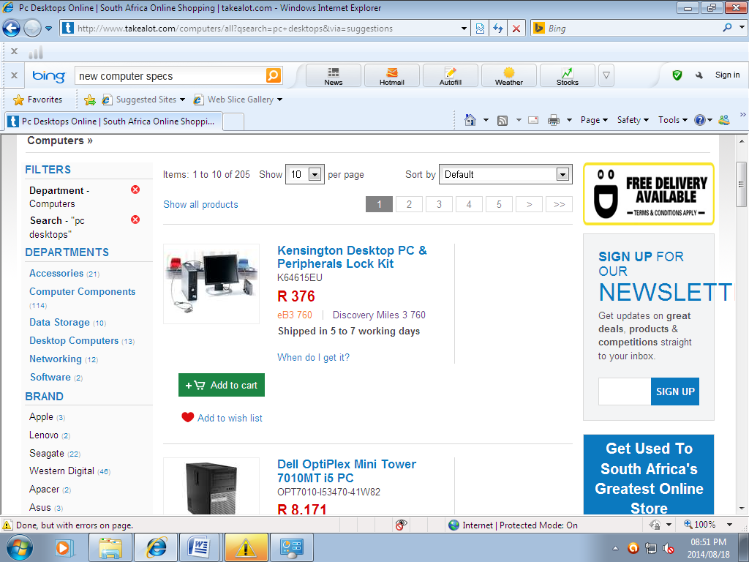

Computer 1

i7 4.6GHz 280 OC Gamer

Intel Core i7 4790K, 8m Cache, 8xCores

MSI Z97 Gaming 7

Overclocked to 4.6GHz

8GB DDR3 1600MHz RAM

128 GB Solid State Drive

Price R18,499.00

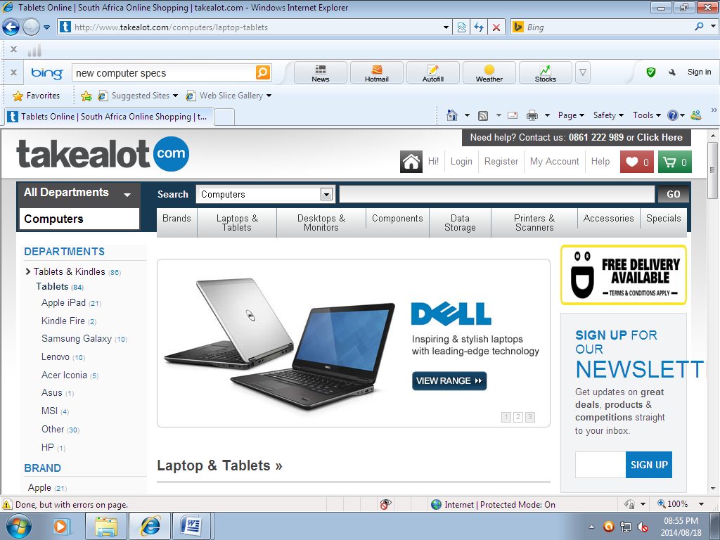

Computer 2

ASUS vivobook S551 La 15.6’’ LED touch Screen

Intel core i5 Ultra Book

3.00GHz CPU, 8M Cache

Windows 8 Pro

8 GB DDR3 RAM

1TB HDD

Price R12,000.00

Computer 3

